**Interpreter design pattern**

Interpretador para a linguagem Gantt.

Localização: ganttproject\src\main\java\net.sourceforge.ganttproject\language\GanttLanguage.java

**Decorator design pattern**

Localização: ganttproject\src\main\java\net.sourceforge.ganttproject\gui\options

Decorator: OptionPageProviderBase

ConcreteDecorators: ProjectBasicOptionPageProvider, ProjectCalendarOptionPageProvider, ProjectRolesOptionPageProvider, ResourceChartOptionPageProvider, entre outros.

**Singleton:** java/net/sourceforge/ganttproject/document/webdav/MiltonResourceFactory.java

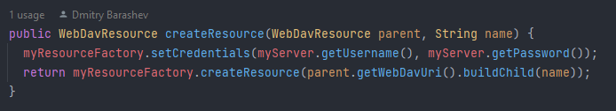

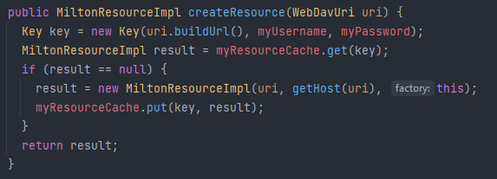

Ensures the creation of only one Milton Resource for each user (given its username and password).